PREVENTION AND DETECTION OF FAKE CHEQUE SCAMS USING BLOCK CHAIN

##### A PROJECT REPORT

###### ***Submitted by***

##### SRIMANJARI P [211418104262]

##### SUBRINI K B [211418104270]

##### SWETHA A R [211418104283]

***in partial fulfillment for the award of the degree***

***of***

**BACHELOR OF ENGINEERING**

IN

# COMPUTER SCIENCE AND ENGINEERING



## PANIMALAR ENGINEERING COLLEGE

**(An Autonomous Institution, Affiliated to Anna University, Chennai)**

**MAY 2022**

**PANIMALAR ENGINEERING COLLEGE**

**(An Autonomous Institution, Affiliated to Anna University, Chennai)**

**BONAFIDE CERTIFICATE**

Certified that this project report **“PREVENTION AND DETECTION OF FAKE CHEQUE SCAMS USING BLOCK CHAIN”** is the bonafide work of “**SRIMANJARI P [REGISTER NO: 211418104262], SUBRINI K B [REGISTER NO: 211418104270], SWETHA A R [REGISTER NO: 211418104283]”** who carried out the project work under my supervision.

**SIGNATURE SIGNATURE**

**Dr.S. MURUGAVALLI, M.E., Ph.D., Mrs.S.T. SANTHANALAKSHMI**

**HEAD OF THE DEPARTMENT SUPERVISOR**

**ASSISTANT PROFESSOR**

**(GRADE I)**

DEPARTMENT OF CSE, DEPARTMENT OF CSE,

PANIMALAR ENGINEERING COLLEGE, PANIMALAR ENGINEERING COLLEGE,

NASARATHPETTAI, NASARATHPETTAI,

POONAMALLEE, POONAMALLEE,

CHENNAI-600 123. CHENNAI-600 123.

Certified that the above candidate(s) was/ were examined in the Anna University Project Viva-Voce Examination held on...........................

**INTERNAL EXAMINER EXTERNAL EXAMINER**

**DECLARATION BY THE STUDENT**

We **SRIMANJARI P [211418104262], SUBRINI K B [211418104270], SWETHA A R[211418104283]** hereby declare that this project report titled “**PREVENTION AND DETECTION OF FAKE CHEQUE SCAMS USING BLOCK CHAIN**” , under the guidance of **Mrs.S.T.SANTHANALAKSHMI ,ASSISTANT PROFESSOR (GRADE I)** is the original work done by us and we have not plagiarized or submitted to any other degree in any university by us.

##### SRIMANJARI P

##### SUBRINI K B

##### SWETHA A R

**ACKNOWLEDGEMENT**

We would like to express our deep gratitude to our respected Secretary and Correspondent **Dr.P. CHINNADURAI, M.A., Ph.D.** for his kind words and enthusiastic motivation, which inspired us a lot in completing this project.

We express our sincere thanks to our Directors **Tmt.C.VIJAYARAJESWARI**, **Dr.C.SAKTHIKUMAR,M.E.,Ph.D** and **Dr.SARANYASREE SAKTHI KUMAR B.E.,M.B.A.,Ph.D.,** for providing us with the necessary facilities to undertake this project.

We also express our gratitude to our Principal **Dr.K.Mani, M.E., Ph.D.** who facilitated us in completing the project.

We thank the Head of the CSE Department, **Dr. S. MURUGAVALLI, M.E., Ph.D.,** for the support extended throughout the project.

We would like to thank my **Project Guide** **Mrs.S.T. SANTHANALAKSHMI, ASSISTANT PROFESSOR (GRADE I)** and all the faculty members of the Department of CSE for their advice and encouragement for the successful completion of the project.

##### SRIMANJARI P

##### SUBRINI K B

##### SWETHA A R

**ABSTRACT**

Fake cheque scam is one of the most common attacks used to commit fraud against consumers. Currently, there is no existing solution to authenticate cheques and detect fake ones instantly. Instead, banks must wait for a period of more time and date to detect the scam. More precisely, our approach helps the banks to share information about provided cheques and used ones, without exposing the banks’ customers’ personal data. Fake cheques come in many forms. They might look like business or personal cheques, cashier’s cheques, money orders, or a cheque delivered electronically. These scams work because fake cheques generally look just like real cheques, even to bank employees. They are often printed with the names and addresses of legitimate financial institutions. Banks are maintaining security services for money transaction to customer security purpose directly cheque with customer and requires their permission. It also charity trust their have Register login and approved by main branch and charity needed send to user and if user need to help charity, they can help by give cheque to charity which passed to bank and amount is transaction to charity and the details about charity amount transaction will send to main branch and maintained by main branch. If response received from concern customer only, transaction will be happened.

TABLE OF CONTENTS

| **CHAPTER NO.** | **TITLE** | **PAGE NO.** |
| --- | --- | --- |
|  | **ABSTRACT** | v |
|  | **LIST OF TABLES** | viii |
|  | **LIST OF FIGURES** | ix |
|  | **LIST OF SYMBOLS, ABBREVIATIONS** | xi |
| **1.** | **INTRODUCTION** |  |
|  | 1.1 Problem Definition | 2 |
|  | 1.2 Scope of the project | 2 |
| **2.** | **LITERATURE SURVEY** | 3 |
| **3.** | **SYSTEM ANALYSIS** |  |
|  | 3.1 Existing System | 10 |
|  | 3.2 Proposed system | 10 |
|  | 3.3 Feasibility Study | 11 |
|  | 3.4 Hardware Environment | 12 |
|  | 3.5 Software Environment | 12 |
| **4.** | **SYSTEM DESIGN** |  |
|  | 4.1. ER diagram | 14 |
|  | 4.2 Data dictionary | 15 |
|  | 4.3 Data Flow Diagram | 18 |
|  | 4.4 UML Diagram | 20 |
|  |  |  |
|  |  |  |
| **5.** | **SYSTEM ARCHITECTURE** |  |
|  | 5.1 System Architecture | 27 |
|  | 5.2 Module Design Specification | 28 |
|  | 5.3 Algorithms | 33 |
| **6.** | **SYSTEM IMPLEMENTATION** |  |
|  | 6.1 Client-side coding | 36 |
|  | 6.2 Server-side coding | 54 |
| **7.** | **SYSTEM TESTING** |  |
|  | 7.1 Test Cases & Reports | 72 |
| **8.** | **CONCLUSION** |  |
|  | 8.1 Conclusion | 76 |
|  | 8.2 Future Enhancements | 76 |
|  | **APPENDICES** |  |
|  | A.1 Sample Screens | 77 |
|  | **REFERENCES** | 84 |

**LIST OF TABLES**

|  |  |  |
| --- | --- | --- |
| **TABLE NO.** | **TABLE DESCRIPTION** | **PAGE NO.** |
| 4.1 | CHARITY REGISTER | 15 |
| 4.2 | PUBLIC REGISTER | 15 |
| 4.3 | CHARITY REQUEST | 16 |
| 4.4 | CHEQUE DETAILS | 16 |
| 4.5 | MONEY TRANSFERED | 17 |
| 4.6 | MONEY TRANSFERRING | 17 |
| 7.1 | CHARITY MANAGEMENT | 72 |
| 7.2 | CHARITY | 72 |
| 7.3 | PUBLIC | 73 |
| 7.4 | BANK | 74 |

**LIST OF FIGURES**

|  |  |  |
| --- | --- | --- |
| **FIG NO.** | **FIGURE DESCRIPTION** | **PAGE NO.** |
| 4.1  4.1 | ER DIAGRAM | 14 |
| 4.2 | DFD LEVEL 0 | 18 |
| 4.3 | DFD LEVEL 1 | 18 |
| 4.4 | DFD LEVEL 2 | 19 |
| 4.5 | USE CASE DIAGRAM | 20 |
| 4.6 | STATE DIAGRAM | 21 |
| 4.7 | ACTIVITY DIAGRAM | 22 |
| 4.8 | CLASS DIAGRAM | 23 |
| 4.9 | SEQUENCE DIAGRAM | 24 |
| 4.10 | COLLABORATION DIAGRAM | 25 |
| 5.1 | SYSTEM ARCHITECTURE | 27 |
| 5.2  5.2.1-5.2.12 | CHARITY REGISTER | 28 |
| 5.3 | CHARITY LOGIN | 28 |
| 5.4 | CHARITY REQUEST | 29 |
| 5.5 | CHARITY REQUEST VIEW | 29 |
| 5.6 | CHARITY DONATION VIEW | 29 |
| 5.7 | BANK RESPONSE VIEW | 30 |
| 5.8 | VIEW ACCOUNT BALANCE | 30 |
| 5.9 | PUBLIC REGISTER | 31 |
| 5.10 | PUBLIC LOGIN | 31 |
| 5.11 | RESPONSE | 31 |
| 5.12 | ADMIN LOGIN | 32 |
| 5.13 | RESPONSE (BANK) | 32 |
| A.1 | MAIN PAGE | 77 |
| A.2 | CHARITY MANAGEMENT LOGIN | 77 |
| A.3 | CHARITY MANAGEMENT MAIN PAGE | 78 |
| A.4 | CHARITY APPROVE PAGE | 78 |
| A.5 | CHARITY COMPLAINT VIEW | 79 |
| A.6 | CHARITY LOGIN PAGE | 79 |
| A.7 | CHARITY REGISTER PAGE | 80 |
| A.8 | CHARITY MAIN PAGE | 80 |
| A.9 | CHARITY ACCOUNT VIEW | 81 |
| A.10 | PUBLIC LOGIN PAGE | 81 |
| A.11 | REGISTER PAGE | 82 |
| A.12 | PUBLIC MAIN PAGE | 82 |
| A.13 | PUBLIC REQUEST VIEW | 83 |
| A.14 | CHEQUE VIEW PAGE | 83 |

**LIST OF SYMBOLS**



|  |  |  |  |
| --- | --- | --- | --- |
| **S.NO** | **NOTATION NAME** | **NOTATION** | **DESCRIPTION** |
| 1. | Class | *Class Name*  *-attribute*  *-attribute*  *+operation*  *+operation*  *+operation*  *+ public*  *-private*  *# Protected* | Represents a collection of similar entities grouped together. |
| 2. | Association | name  Class B  Class A  Class A  Class B | Associations represents static relationships between classes. Roles represents the way the two classes see each other. |
| 3. | Actor | Class A  Class A  Class B  Class B | It aggregates several classes into a single class. |
| 4. | Aggregation | Interaction between the system and external environment |



|  |  |  |  |
| --- | --- | --- | --- |
| 5. | Relation  (uses) | uses | Used for additional process communication. |
| 6. | Relation  (extends) | extends | Extends relationship is used when one use case is similar to another use case but does a bit more. |
| 7. | Communication |  | Communication between various use cases. |
| 8. | State | State | State of the process. |
| 9. | Initial State |  | Initial state of the object |
| 10. | Final state |  | Final state of the object |
| 11. | Control flow |  | Represents various control flow between the states. |
| 12. | Decision box |  | Represents decision making process from a constraint |
| 13. | Usecase |  | Interact ion between the system and external environment. |

|  |  |  |  |
| --- | --- | --- | --- |
| 14. | Component |  | Represents physical modules which is a collection of components. |
| 15. | Node |  | Represents physical modules which are a collection of components. |
| 16. | Data Process/State |  | A circle in DFD represents a state or process which has been triggered due to some event or acion. |
| 17. | External entity |  | Represents external entities such as keyboard, sensors, etc. |
| 18. | Transition |  | Represents communication that occurs between processes. |
| 19. | Object Lifeline |  | Represents the vertical dimensions that the object communications. |
| 20. | Message | Message | Represents the message exchanged. |

**LIST OF ABBREVATION**

|  |  |  |
| --- | --- | --- |
| **S.NO** | **ABBREVATION** | **EXPANSION** |
| 1**.** | DB | Data Base |
| 2. | SMC | Secure Multiparty Computation |
| 3. | MDA | Medical Admin |
| 4. | DBC | Data Base Confidentiality |
| 5. | JVM | Java Virtual Machine |
| 6. | JSP | Java Server Page |

**1.INTRODUCTION**

**1.INTRODUCTION**

**1.1 PROBLEM DEFINITION**

In our current society, cheques represent one of the dominant payment methods. A cheque is an order written by the depositor instructing the bank to pay a specific amount to a recipient from the depositor’s bank account. Unfortunately, numerous malicious scammers exploit some flaws in the banking system to commit frauds. Indeed, frauds employing fake cheques are growing rapidly and cost billions of money. we focus on fake cheque scams. This fraud is achieved by getting people mainly through some email scam, establishing a relationship a business relationship most of the time sending them overpaid counterfeit paycheque and finally asking for the overpayment.

**1.2 SCOPE OF THE PROJECT**

The threat of online fraud has spurred many charity companies and financial institutions to alert consumers when potentially fraudulent transactions are made. Blockchain can help to reduce and even prevent fraud in the supply chain through greater transparency and improved traceability of products.  It’s very difficult to manipulate the blockchain. In this project bank will return the cheque leaf to the customer when bank find the charity is fake.

**2.LITERATURE SURVEY**

**2.LITERATURE SURVEY**

1. **Badis Hammi, Sherali Zeadally, Yves Christian Elloh Adja, Manlio Del**

**Giudice,and Jamel Nebhen, 2021,“Blockchain-Based Solution for Detecting and preventing Fake Cheque Scams” Published in IEEE Transaction on Engineering Management**

This paper uses the methodology Digital Signature Algorithm.In this context, we propose a blockchain-based scheme to authenticate checks and detect fake check scams. Moreover, our approach allows the revocation of used checks.The merit is the signature provide authenticity and ensure that the signature is verified and the demerit is it requires a lot of time to authenticate the verification process.

1. **Emart 77, Beirut,Lebanon, 2021,“The Role of Blockchain in Reducing the Cost of Financial Transactions in the Retail Industry” Published in WCNC**

This paper uses the methodology Consumer Package Goods. The aim of this paper was to assess the role of blockchain in reducing the cost of financial transactions in the retail industry. The merits is Consumer packaged goods (CPG) – and to some extent, services is arguably one of the most challenging industries to be successful in. And the demerit is Being a consumer limited resource that they are forced to accept. This includes the limitations on income and the way these decision influence consumer interest in a product.

1. **Dilip Kumar Sharma, Sonal Garg, Priya Shrivastava, 2021,“Evaluation of Tools and Extension for Fake News Detection” Published in IEEE International Conference on Innovation Practice in Technology Management (ICIPTM)**

This paper uses the methodology Bi-LSTM classifier. Merit in this It is a sequence prediction model. It is a discriminative classifier which model the decision boundary between different classes and demerit is Since Bi- LSTM has double LSTM cells so it is costly. Not Good fit for Speech Recognition.

1. **Vikash Kumar Aggarwal, Nikhil Sharma, Ila Kaushik, Bharat Bhushan, Himanshu, 2020, “Integration of Blockchain and IoT (B-IoT): Architecture,** **Solution, & Future Research Direction” Published in 1st International Conference on Computational Research and Data Analytics (ICCRDA).**

This paper uses the methodology Integration of Blockchain and IoT.In this paper, we present introductory part of IoT enabled with blockchain, their key features, architecture layout, characteristic features of both the technologies, their futuristic solutions for different real-world problems, different communicational models. The merit is the smart contract is what allows a smart device to function on its own without the need for a centralized authority and the demerit is one of the notable weaknesses of blockchain is scalability while blockchain is not indestructible.

1. **Jackie Jones, Damon McCopy, 2020, “The Cheque is in the Mail: Monetization of Craigslist Buyer Scams” Published in IEEE APWG Symposium**.

This paper uses the Methodology Conservation Classification Strategy.In this paper we extend on previous works about fake payment scams targeting Craigslist. To grow our understanding of scammer methods and how they monetize these scams.The merit is Compared to manual data entry automatic data entry greatly reduced errors. Company documents can be filled out, stored, retrieved and used more accurately and the demerit is Automated equipment include the high capital expenditure required to invest in automation.

1. **Abiola, Idowu, 2019, “An Assessment of Fraud and its Management in**

**Nigeria Commercial Banks” Published in IEEE Paper European Journal of Social Science.**

This paper uses the Methodology Pearson Product Moment Correlation Coefficient. This aims at finding practical means of minimizing the incidence of fraud in Nigerian banks. During the course of the investigation efforts were made to identify various means employed in defrauding banks and at the same time determine the effects of fraud on the banking services. Merit in this is a correlation coefficient such as Pearson r is that it provides effect size information (in unit free terms) and the demerit is a key limitation of Pearson’s r is that it cannot distinguish between independent and dependent variables. Therefore, also if a relationship between two variables is found.

1. **Sumeet Kumar, 2018, “Simulating DDOS attacks on the us fiber-optics**

**internet infrastructure” Published in Proceedings of the 2017 Winter Simulation Conference.**

This paper uses the Methodology Cyber-attacks.In this research, we have designed a test-bed that mirrors the Internet infrastructure of the US and can simulate the Internet traffic flow patterns for different attack targets. We also estimate the degradation in the quality-of-service and the number of users impacted in two attack scenarios.The merit is a network simulation model to understand the Internet traffic flow pattern in a DDOS attack situation and the demerit is Altering data through remote access or damage the system causing data loss.

1. **Nazli Ismail Nawang , 2017,“ Combating anonymous offenders in the cyberspace: An overview of the legal approach in Malaysia” Published in conference**

This feature is most commonly cherished by Internet users as they are empowered to publish online content anonymously; or in the alternative to conceal their true identities behind fictitious names (pseudonyms).Merit is It identifies the anonymous offender in the cyber world and demerit is the user must know the various laws that have been enacted to govern publication of illegal content.

1. **Haris S emic, Sasa Mrdovic, 2017, “IoT honeypot: A multi-component solution for handling manual and Mirai-based attacks” Published in: IEEE 25th Telecommunication forum TELFOR 2017.**

This paper uses the Methodology Internet-of-things (IoT) device.This paper proposes an implementation of honeypot that detects and reports telnet attacks on Internet-of-Things (IoT) devices. The honeypot operates with manual and Mirai-based attacks.Merit in this It is used to attain sufficient exposure to malicious traffic and security of collected data and demerit is the plank of security has left IoT devices vulnerable to various attacks that aim to take control of said devices and utilize them for various malicious purposes.

1. **Bernie S.Fabito,Angelique D.Lacasandile ,Emeliza R.Yabut ,2017 ,“Leveraging crime reporing in Metro Manila using unsupervised crowd-sourced data: A case for the Report framework” Published in International Conference on control, electronics, renewable energy and communication.**

This paper uses the Methodology Ping ER Monitoring Agent.It aims to provide a venue for victims of crimes to report their experiences without having to go directly to police stations. Those who have experienced the same offense in the area can link their reports with those previously reported offenses which refer to the same case.Merit is In this layer, existing ping ER scripts which generate hourly, monthly and yearly reports can work seamlessly. This is because, in this framework, contents are addressed through hashes which is a widely used means of connecting data in a distributed network and demerit is the downside of using an always-free tool is that it may be missing key features that you need. And with always-free tools, what you get is what you get.

1. **Wendy Baker-Smemoe, Chair David Eddington William G. Eggington, 2015, “The Language and Cross-Culture Perceptions of Deception” Published in: Brigham young university.**

This paper uses the Methodology Qualtrics Survey Block. research has shown that some linguistic features can indicate a person is lying, this line of research has led to conflicting results. Furthermore, very little research has been done to verify that these supposed linguistic features of deception are universal. In addition, few studies have researched the cross-cultural perceptions of deception, which knowledge could greatly improve the detection of deception across cultures.Merit in this is Rather than creating two surveys, you could create two blocks of questions within one survey and randomly assign participants to one block or the other and the demerit is Qualtrics support could use some work. It can be difficult to find help in the community. It almost has to reach out to someone on the online chat or via email to get help.

**3.SYSTEM ANALYSIS**

**3.SYSTEM ANALYSIS**

**3.1 EXISTING SYSTEM**

**Concept:**

Fake cheque scam has more disastrous consequences on the victims than many other attacks. In this context,we believe that the best solution to protect users is the detection of fake cheques well before they are cashed.

**Technique:**

Digital Signature Algorithm.

**Disadvantage:**

* It requires lot of time for computation.
* Verification of a given take a look at and, for this reason, avoid the modern drift duration of greater than 48 h.

**3.2 PROPOSED SYSTEM**

**Concept:**

To verify the authenticity of a given cheque, without exposing the banks’ customers’ personal data. To evaluate the performance of our proposed approach, we also deployed our cheque’s authentication scheme based on the blockchain.

**Technique:**

SHA algorithm, AES algorithm.

**Advantage:**

* It requires less time than Digital Signature algorithm.
* Bank asking validated consumer and client give the permission the financial institution may be send the cash in charity.

**3.3 FEASIBILITY STUDY**

**TECHNICAL FEASIBILITY**

**HARDWARE REQUIREMENTS**

* PROCESSOR : DUAL CORE 2 DUOS
* RAM : 2 GB DD RAM
* HARD DISK : 250 GB

**SOFTWARE REQUIREMENTS**

* FRONT END : J2EE (JSP, SERVLET)
* BACK END : MY SQL 5.5
* OPERATING SYSTEM : WINDOWS 7
* LANGUAGE : JAVA

**ECONOMIC FEASIBILITY**

* This assessment typically involves a cost/ benefits analysis of the project, helping organizations determine the viability, cost, and benefits associated with a project before financial resources are allocated.
* It also serves as an independent project assessment and enhances project credibility—helping decision-makers determine the positive economic benefits to the organization that the proposed project will provide.

**SOCIAL FEASIBILITY**

* It is helpful for people to save their money from hackers
* It helps the bank to detect the fake cheque instantly

**3.4 HARDWARE ENVIRONMENT**

* PROCESSOR : DUAL CORE 2 DUOS
* RAM : 2 GB DD RAM
* HARD DISK : 250 GB

**3.5 SOFTWARE ENVIRONMENT**

* FRONT END : J2EE (JSP, SERVLET)
* BACK END : MY SQL 5.5
* OPERATING SYSTEM : WINDOWS 7
* IDE : ECLIPSE

**4.SYSTEM DESIGN**

**4.SYSTEM DESIGN**



**4.1 ER DIAGRAM**

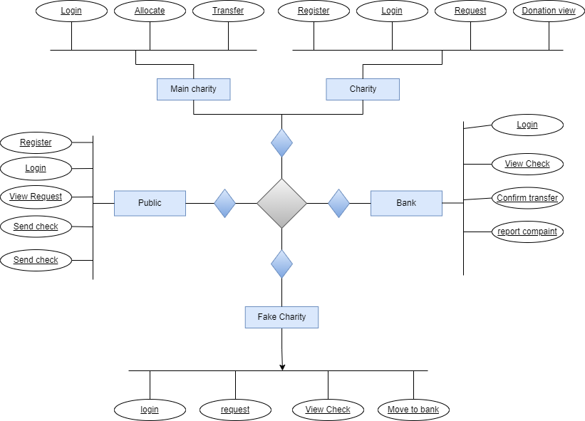



FIG NO. 4. 1 ER DIAGRAM

An entity is represented as rectangle in an ER diagram. For example: In the following ER diagram we have two entities Student and College and these two entities have many to one relationship as many students’ studies in a single college. We will read more about relationships later, for now focus on entities.

**4.2 DATA DICTIONARY**

**4.2.1 CHARITY REGISTRATION**

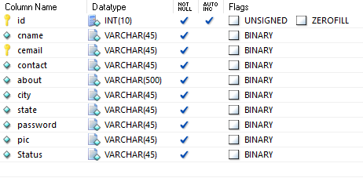

TABLE NO. 4.1 CHARITY REGISTRATION

**4.2.2 PUBLIC REGISTRATION**

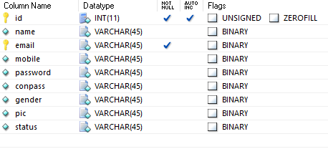

TABLE NO .4.2 PUBLIC REGISTRATION

**4.2.3 CHARITY REQUEST**

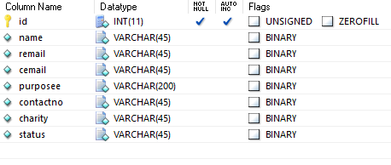

TABLE NO. 4.3 CHARITY REQUEST

**4.2.4 CHEQUE DETAILS**

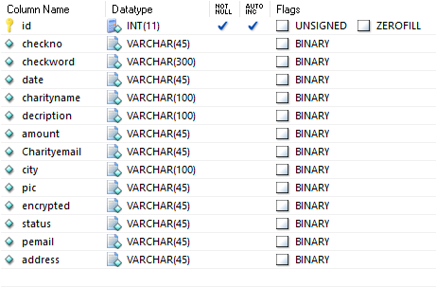

TABLE NO .4.4 CHEQUE DETAILS

**4.2.5 MONEY TRANSFRED**

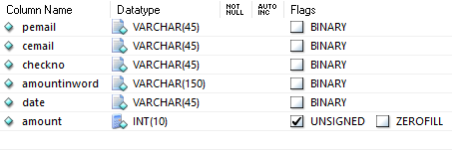

TABLE NO.4.5 MONEY TRANSFERED

**4.2.6 MONEY TRANSFRRING**

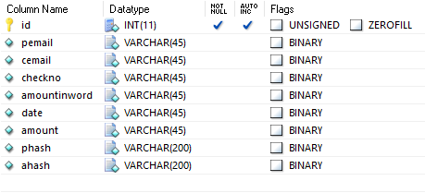

TABLE NO.4.6 MONEY TRANSFERRING

**4.3 DATA FLOW DIAGRAM**

A data flow diagram (DFD) is a graphical representation of the “flow” of data through an information system. It differs from the flowchart as it shows the data flow instead of the control flow of the program. A data flow diagram can also be used for the visualization of data processing. The DFD is designed to show how a system is divided into smaller portions and to highlight the flow of data between those parts.

**LEVEL 0:**

**D:\Sudha\bc1-l1.png**

FIG NO.4.2 DFD LEVEL 0

**LEVEL 1:**

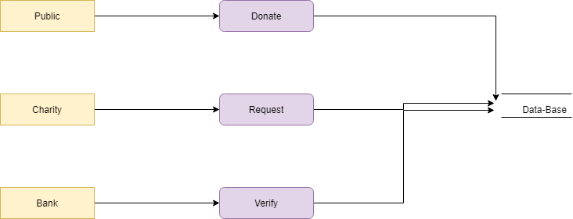

FIG NO .4.3 DFD LEVEL 1

**LEVEL 2:**

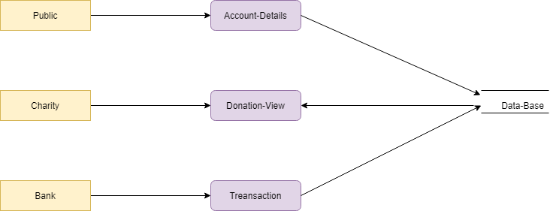

FIG NO.4.4 DFD LEVEL 2

**4.5 UML DIAGRAM**

**4.5.1 USE-CASE DIGRAM:**

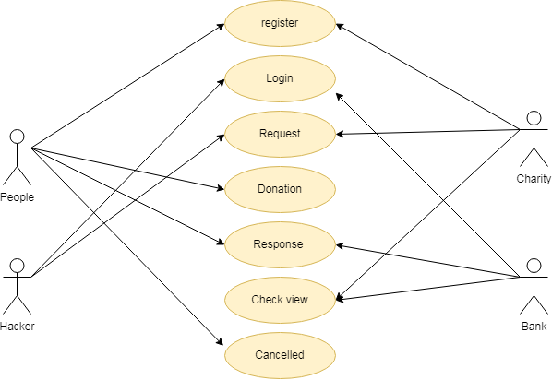

FIG NO.4.5 USE-CASE DIAGRAM

**EXPLANATION:**

The use case diagram is the main building block of [object oriented](http://en.wikipedia.org/wiki/Object_oriented) modeling. It is used both for general [conceptual modeling](http://en.wikipedia.org/wiki/Conceptual_model) of the systematic of the application, and for detailed modeling translating the models into [programming code](http://en.wikipedia.org/wiki/Programming_code). For this in our component diagram first propose a data. In this proposed method we are using Hash-Solomon Code Algorithm to encrypt the data.

**4.5.2 STATE DIAGRAM:**

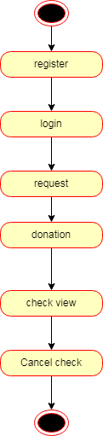

FIG NO.4.6 STATE DIAGRAM

**EXPLANATION:**

State diagrams require that the system described is composed of a finite number of states; sometimes, this is indeed the case, while at other times this is a reasonable abstraction. Many forms of state diagrams exist, which differ slightly and have different semantics. In our state diagram first propose for this in our component diagram first propose a data in this proposed method we are using Hash-Solomon Code Algorithm to encrypt the data.

**4.5.3 ACTIVITY DIAGRAM:**

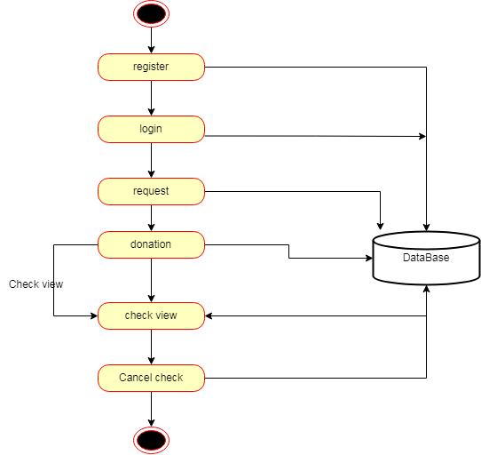



FIG NO.4.7 ACATIVITY DIAGRAM

**EXPLANATION:**

Activity diagram are a loosely defined diagram to show workflows of stepwise activities and actions, with support for choice, iteration and concurrency. UML, activity diagrams can be used to describe the business and operational step-by-step workflows of components in a system. UML activity diagrams could potentially model the internal logic of a complex operation. In many ways UML activity diagrams are the object-oriented equivalent of flow charts and data flow diagrams(DFDs)from structural development.

**4.5.4 CLASS DIGRAM:**

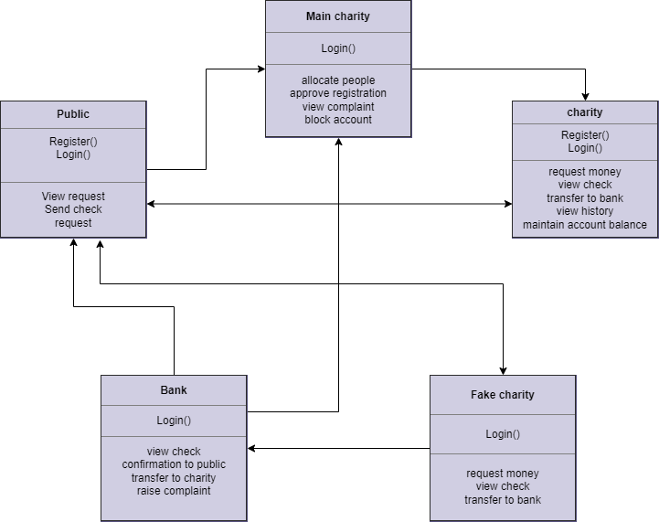

FIG NO.4.8 CLASS DIAGRAM

**EXPLANATION:**

Class diagram is a type of static structure diagram that describes the structure of a system by showing the system's classes, their attributes, and the relationships between the classes. The classes in a class diagram represent both the main objects and or interactions in the application and the objects.

**4.5.5 SEQUENCE DIAGRAM:**

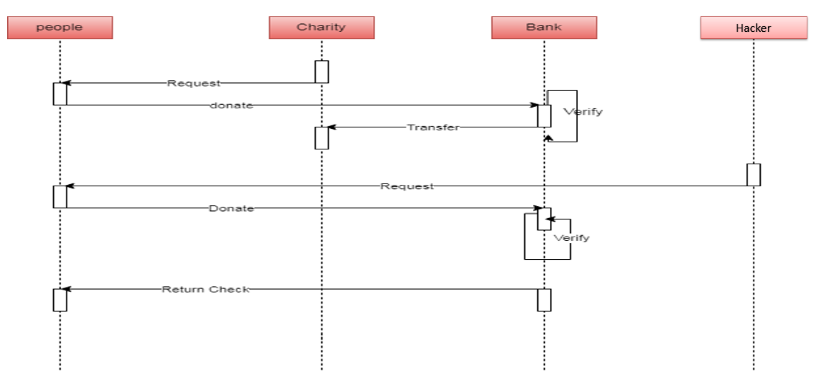

FIG NO.4.9 SEQUENCE DIAGRAM

**EXPLANATION:**

In our sequence diagram specifying processes operate with one another and in order. In our sequence diagram first propose a data. In this proposed method we are using Hash-Solomon Code Algorithm to encrypt the data.

**4.5.6 COLLABORATION DIAGRAM**

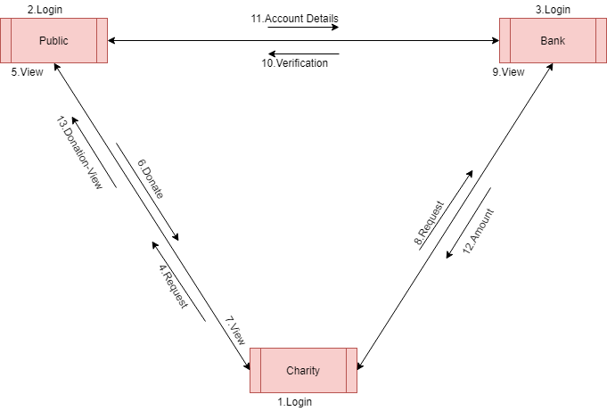

FIG NO.4.10 COLLABORATION DIAGRAM

**EXPLANATION:**

A collaboration diagram shows the objects and relationships involved in an interaction, and the sequence of messages exchanged among the objects during the interaction. The collaboration diagram can be a decomposition of a class, class diagram, or part of a class diagram. it can be the decomposition of a use case, use case diagram, or part of a use case diagram. The collaboration diagram shows messages being sent between classes and object(instances). A diagram is created for each system operation that relates to the current development cycle(iteration).

**5.SYSTEM ARCHITECTURE**

**5.SYSTEM ARCHITECTURE**

**5.1 SYSTEM ARCHITECTURE DIAGRAM**

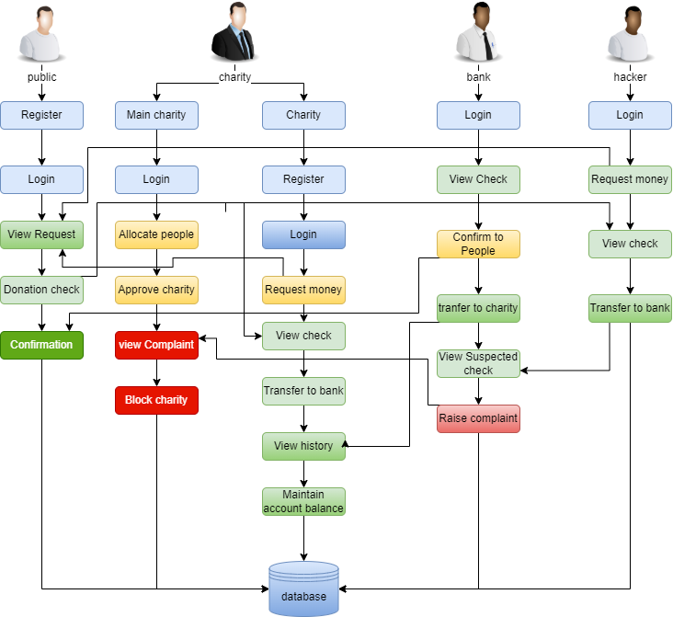

FIG NO 5.1 SYSTEM ARCHITECTURE DIAGRAM

**EXPLANATION:**

The systems architect establishes the basic structure of the system, we propose a Hash code Solomon algorithm and a we can put a small part of data in local machine and fog server in order to protect the privacy. Moreover, based on computational intelligence, this algorithm can compute the distribution proportion stored in cloud, fog, and local machine, respectively. Through the theoretical safety analysis and experimental evaluation, the feasibility of our scheme has been validated, which is really a powerful supplement to existing cloud storage scheme.

**5.2 MODULE DESIGN SPECIFICATION**

**5.2.1 CHARITY REGISTER**

The register module provides a conceptual framework for entering data on those charity in a way that: eases data entry & accuracy by matching the charity entry to the data source (usually paper files created at point of care), ties easily back to individual charity records to connect registers to charity data, and collects data elements to enable better supervision of donation programs.

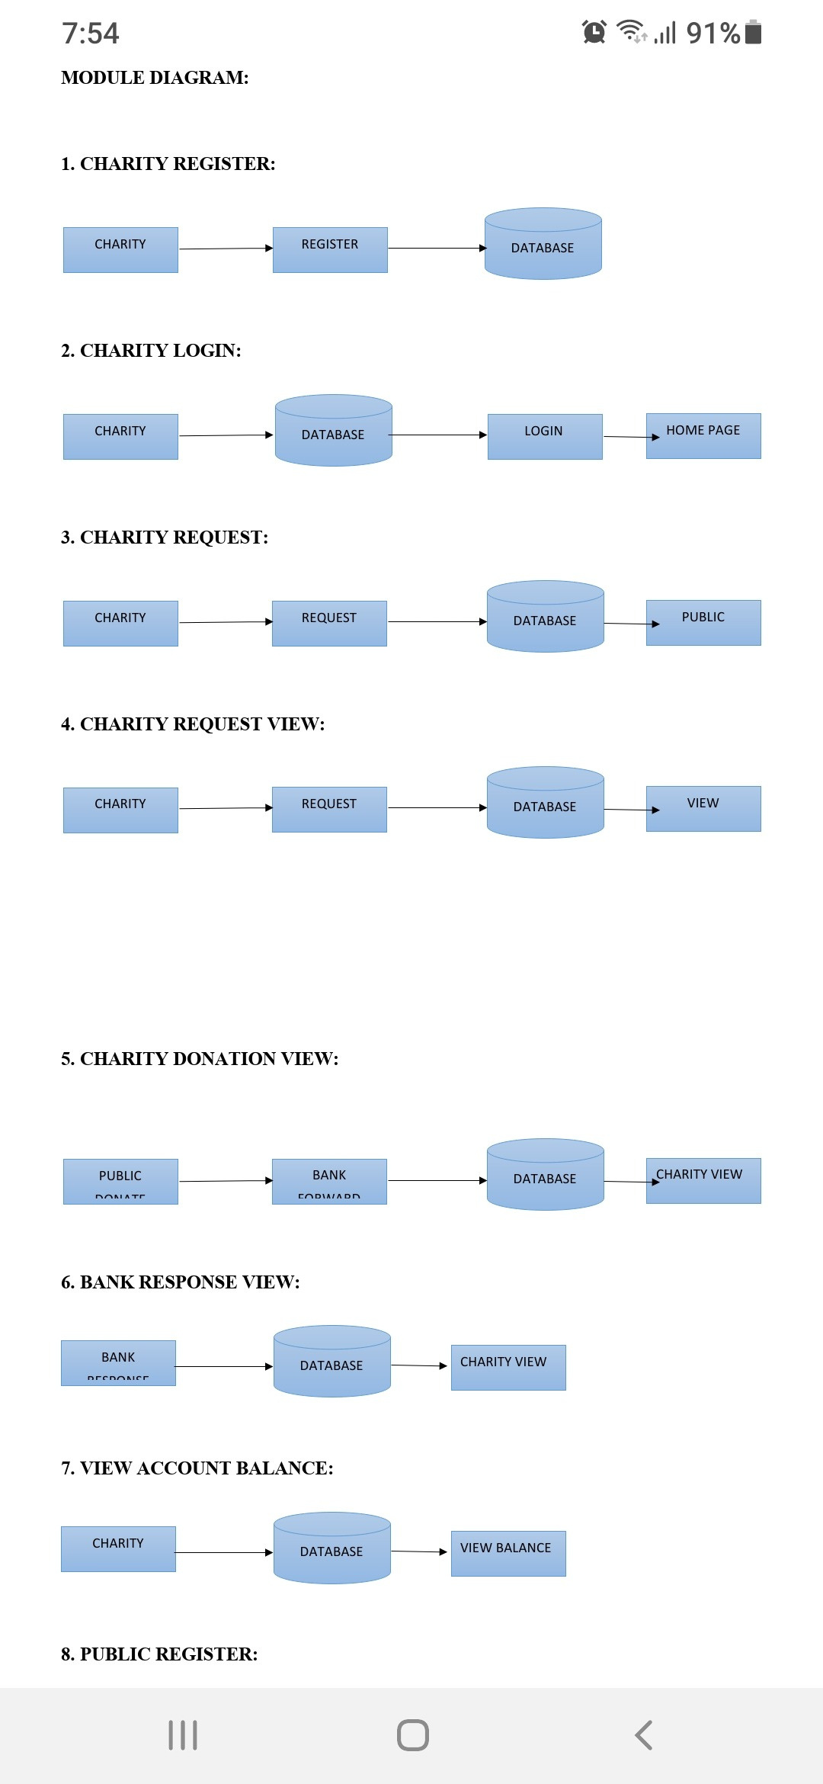

FIG NO. 5.2 CHARITY REGISTER

**5.2.2 CHARITY LOGIN**

Add a subheading in this module in our project, here symbolizes a unit of work performed within a database management system (or similar system) against a database, and treated in a coherent and reliable way independent of other transactions. A transaction generally represents any change in database user will transfer the amount to provider.

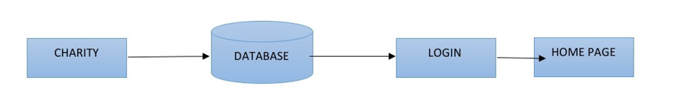

FIG NO. 5.3 CHARITY LOGIN

**5.2.3 CHARITY REQUEST**

In this module is used to help to the user to Request for donation with the land longitude and the user will update the report along with their opinion and they will be stored the database.

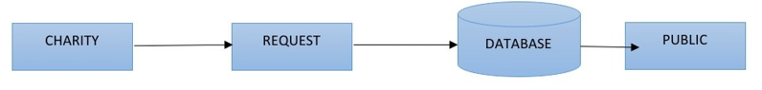

FIG NO.5.4 CHARITY REQUEST

**5.2.4 CHARITY REQUEST VIEW**

In this module the charity will also view the request. And analysis the details will be responsible for your file stored in database.

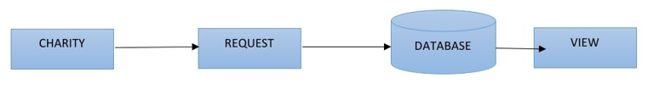

FIG NO.5.5 CHARITY REQUEST VIEW

**5.2.5 CHARITY DONATION VIEW**

In this module the charity will also view the donation. And analysis the details will be responsible for your file stored in database.

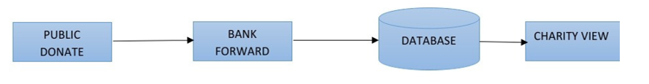

FIG NO.5.6 CHARITY DONATION VIEW

**5.2.6 BANK RESPONSE VIEW**

In this module the charity will also view the donation. And analysis the details will be responsible for your file stored in database.

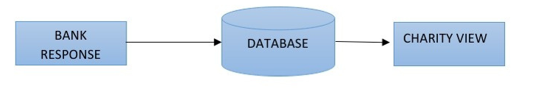

FIG NO. 5.7 BANK RESPONSE VIEW

**5.2.7 VIEW ACCOUNT BALANCE**

In this module the charity will also view the account balance. And analysis the details will be responsible for your file stored in database.

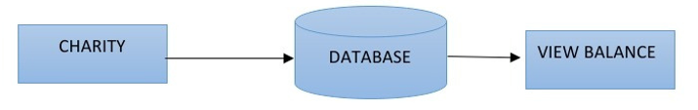

FIG NO. 5.8 VIWE ACCOUNT BALANCE

**5.2.8 PUBLIC REGISTER**

The register module provides a conceptual framework for entering data on those charity in a way that: eases data entry & accuracy by matching the charity entry to the data source (usually paper files created at point of care), ties easily back to individual charity records to connect registers to charity data, and collects data elements to enable better supervision of donation programs.

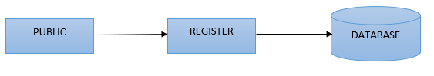

FIG NO 5.9 PUBLIC REGISTER

**5.2.9 PUBLIC LOGIN**

In this module in our project, here symbolizes a unit of work performed within a database management system (or similar system) against a database, and treated in a coherent and reliable way independent of other transactions. A transaction generally represents any change in database user will transfer the amount to provider.



FIG NO. 5.10 PUBLIC LOGIN

**5.2.10 RESPONSE**

In this module the bank will response the data file fully analyzed data in category wise view Bank will be responsible for your file stored in database.

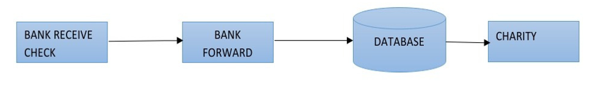

FIG NO. 5.11 RESPONSE

**5.2.11 ADMIN LOGIN**

In this module in our project, here symbolizes a unit of work performed within a database management system (or similar system) against a database, and treated in a coherent and reliable way independent of other transactions. A transaction generally represents any change in database user will transfer the amount to provider.

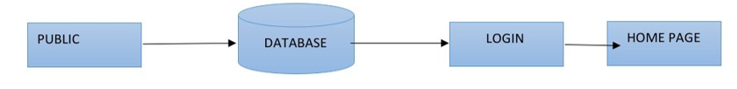

FIG NO 5.12 ADMIN LOGIN

**5.2.12 RESPONSE (BANK)**

In this module is used to help to the public to donation the amount with the land longitude and the public will update the report along with their opinion and the will be stored the database.



FIG NO 5.13 RESPONSE (BANK)

**5.3 ALGORITHM**

**SHA ALGORITHM**

* In the field of cryptography and crypt analytics, the SHA-1 algorithm is a crypt-formatted hash function that is used to take a smaller input and produces a string that is 160 bits, also known as 20-byte hash value long.
* The hash value therefore generated, is known as a message digest which is typically rendered and produced as a hexadecimal number which is specifically 40 digits long.

CHARACTERISTICS

* The cryptographic hash functions are utilized and used to keep and store the secured form of data by providing three different kinds of characteristics such as pre-image resistance, which is also known as the first level of image resistance, the second level of pre-image resistance and collision resistance.
* The cornerstone lies in the fact that the pre-image crypt resistance technique

makes it hard and more time consuming for the hacker or the attacker to find the original intended message by providing the respective hash value.

* The security, therefore, is provided by the nature of a one way that has a function that is mostly the key component of the SHA algorithm. The pre-image resistance is important to clear off brute force attacks from a set of huge and powerful machines.
* Similarly, the second resistance technique is applied where the attacker has to go through a hard time decoding the next error message even when the first level of the message has been decrypted. The last and most difficult to crack is the collision resistance, making it extremely hard for the attacker to find two completely different messages which hash to the same hash value.
* Therefore, the ratio to the number of inputs and the outputs should be similar in fashion to comply with the pigeonhole principle. The collision resistance implies that finding two different sets of inputs that hash to the same hash is extremely difficult and therefore marks its safety.

**USES OF SHA ALGORITHM**

* These SHA algorithms are widely used in security protocols and applications, including the ones such as TLS, PGP, SSL, IPsec, and S/MiME.
* These also find their place in all the majority of cryptanalytic techniques and coding standards which is mainly aimed to see the functioning and working of majorly all governmental as well as private organizations and institutions.
* Major giants today such as Google, Microsoft, or Mozilla have started to recommend the use of SHA-3 and stop the usage of the SHA-1 algorithm.

**6.SYSTEM IMPLEMENTATION**

**6.SYSTEM IMPLEMENTATION**

**6.1 CLIENT-SIDE CODING**

**Web Content:**

**Homepage.jsp:**

<%@ page language=”java” contentType=”text/html; charset=ISO-8859-1”

pageEncoding=”ISO-8859-1”%>

<!DOCTYPE html PUBLIC “-//W3C//DTD HTML 4.01 Transitional//EN” “http://www.w3.org/TR/html4/loose.dtd”>

<html>

<head>

<meta http-equiv=”Content-Type” content=”text/html; charset=ISO-8859-1”>

<title>Homepage</title>

<style>

ul {

list-style-type: none;

margin: 0;

padding: 0;

overflow: hidden;

background: linear-gradient(to right, #0000ff 0%, #00ffff 100%);

}

li {

float: right;

padding-right:185px;

}

li a {

display: block;

color: white;

text-align: center;

text-style:bold;

padding: 14px 16px;

text-decoration: none;

}

body {

background-image: url(“bgimages/charity1.jpg”);

background-repeat: no-repeat;

background-size: cover;

}

</style>

</head>

<body>

<ul>

<li><a href=”banklogin.jsp”>Bank</a></li>

<li><a href=”publiclogin.jsp”>Public</a></li>

<li><a href=”charitylogin.jsp”>Charity</a></li>

</ul>

</body>

</html>

**Publicregister.jsp;**

<%@ page language=”java” contentType=”text/html; charset=ISO-8859-1”

pageEncoding=”ISO-8859-1”%>

<%-- <%@page import=”dbconn.Dbconn”%> --%>

<%@page import=”java.sql.ResultSet”%>

<%@page import=”java.sql.PreparedStatement” %>

<%@page import=”java.sql.*” %>

<%@page import=”java.util.*” %>

<!DOCTYPE html PUBLIC “-//W3C//DTD HTML 4.01 Transitional//EN” “http://www.w3.org/TR/html4/loose.dtd”>

<html>

<head>

<meta http-equiv=”Content-Type” content=”text/html; charset=ISO-8859-1”>

<title>Insert title here</title>

<style>

.myDiv {

border: 5px outset #ff0000;

background-color: lightyellow;

border-radius: 10px;

width:600px;

height:400px;

margin: auto;

padding-top:30px;

box-shadow: 25px 20px 20px #888888;

}

.myDiv2 {

font-size:25px;

font-style: italic;

font-weight: bold;

color: #ffffff;

}

body{

background-image: linear-gradient(to top, lightyellow,maroon);

}

</style>

</head>

<body>

<br><br>

<center>

<div class=”myDiv2”>

Public Register

</div>

</center>

<br>

<div class=”myDiv”>

<center>

<form action=”Publicregservlet” method=”post”>

<input type=”text” name=”username” placeholder=”Username” style=”width:280px;height:40px;border-radius: 10px;text-align:center;”><br><br>

<input type=”text” name=”phonenumber” placeholder=”Phonenumber” style=”width:280px;height:40px;border-radius: 10px;text-align:center;”><br><br>

<input type=”text” name=”email” placeholder=”Emaiid” style=”width:280px;height:40px;border-radius: 10px;text-align:center;”><br><br>

<input type=”text” name=”password” placeholder=”Password” style=”width:280px;height:40px;border-radius: 10px;text-align:center;”><br><br>

<input type=”submit” value=”Submit” style=”width:100px;height:40px;border-radius: 10px;”><br><br>

</form>

</center>

</div>

</body>

</html>

**Publicmainpage.jsp**

<%@ page language=”java” contentType=”text/html; charset=ISO-8859-1”

pageEncoding=”ISO-8859-1”%>

<!DOCTYPE html PUBLIC “-//W3C//DTD HTML 4.01 Transitional//EN” “http://www.w3.org/TR/html4/loose.dtd”>

<html>

<head>

<meta http-equiv=”Content-Type” content=”text/html; charset=ISO-8859-1”>

<title>Insert title here</title>

<style>

ul {

list-style-type: none;

margin: 0;

padding: 0;

overflow: hidden;

background-color: #4bc99b;

}

li {

float: right;

padding-right:185px;

}

li a {

display: block;

color: white;

text-align: center;

text-style:bold;

padding: 14px 16px;

text-decoration: none;

}

.myDiv2 {

font-size:25px;

font-style: italic;

font-weight: bold;

color:green;

}

body {

background-image: url(“bgimages/charity3.jpg”);

background-repeat: no-repeat;

background-size: cover;

/* background: linear-gradient(to bottom, #996633 0%, #ff66cc 100%); */

/* background-image: linear-gradient(to right, red , yellow); */

}

</style>

</head>

<body>

<ul>

<li><a href=”homepage.jsp”>Logout</a></li>

<li><a href=”publicresptobank.jsp”>Response(Bank)</a></li>

<li><a href=”publicrequview.jsp”>Request(Charity)</a></li>

<li><a href=”homepage.jsp”>Home</a></li>

</ul>

<br><br>

<center>

<div class=”myDiv2”>

Public Mainpage

</div></center>

</body>

</html>

**Charitylogin.jsp:**

<%@ page language=”java” contentType=”text/html; charset=ISO-8859-1”

pageEncoding=”ISO-8859-1”%>

<!DOCTYPE html PUBLIC “-//W3C//DTD HTML 4.01 Transitional//EN” “http://www.w3.org/TR/html4/loose.dtd”>

<html>

<head>

<meta http-equiv=”Content-Type” content=”text/html; charset=ISO-8859-1”>

<title>Insert title here</title>

<style>

.myDiv {

border: 5px outset red;

background-color: lightgreen;

border-radius: 10px;

width:600px;

height:200px;

margin: auto;

padding-top:30px;

/* box-shadow: 25px 20px 20px #888888; */

}

.myDiv2 {

font-size:25px;

font-style: italic;

font-weight: bold;

color:white;

}

body{

/* background-image: linear-gradient(to bottom, #00ccff 0%, #33cc33 100%); */

background-image: linear-gradient(to top, lightblue, blue);

}

</style>

</head>

<body>

<br><br><br>

<center>

<div class=”myDiv2”>

Charity Login Page

</div>

</center>

<br><br>

<form action=”Charityloginservlet” method=”post”>

<div class=”myDiv”>

<center>

<input type=”text” name=”username” placeholder=”Username” style=”width:280px;height:40px;border-radius: 10px;text-align:center;”><br><br>

<input type=”text” name=”password” placeholder=”Password” style=”width:280px;height:40px;border-radius: 10px;text-align:center;”><br><br>

<input type=”submit” value=”Submit” style=”width:100px;height:40px;border-radius: 10px;background-color:green;”><br><br>

</center>

</div>

</form>

</body>

</html>

**Charitymainpage.jsp:**

<%@ page language=”java” contentType=”text/html; charset=ISO-8859-1”

pageEncoding=”ISO-8859-1”%>

<!DOCTYPE html PUBLIC “-//W3C//DTD HTML 4.01 Transitional//EN” “http://www.w3.org/TR/html4/loose.dtd”>

<html>

<head>

<meta http-equiv=”Content-Type” content=”text/html; charset=ISO-8859-1”>

<title>Insert title here</title>

<style>

ul {

list-style-type: none;

margin: 0;

padding: 0;

overflow: hidden;

background-color: #cccc00;

}

li {

float: right;

padding-right:85px;

}

li a {

display: block;

color: white;

text-align: center;

text-style:bold;

padding: 14px 16px;

text-decoration: none;

}

.myDiv2 {

font-size:25px;

font-style: italic;

font-weight: bold;

color:green;

}

body {

background-image: url(“bgimages/charity4.jpg”);

background-repeat: no-repeat;

background-size: cover;

/* background: linear-gradient(to bottom, #996633 0%, #ff66cc 100%); */

/* background-image: linear-gradient(to right, red , yellow); */

}

</style>

</head>

<body>

<ul>

<li><a href=”homepage.jsp”>Logout</a></li>

<li><a href=”charityaccount.jsp”>Account</a></li>

<li><a href=”bankapprovtocharity.jsp”>Response(Bank)</a></li>

<li><a href=”charitydonationview.jsp”>Donation</a></li>

<li><a href=”charitypubreqview.jsp”>RequestView</a></li>

<li><a href=”charityrequest.jsp”>Request</a></li>

<li><a href=”homepage.jsp”>Home</a></li>

</ul>

<br><br>

<center>

<div class=”myDiv2”>

Charity Mainpage

</div></center>

</body>

</html>

**Charityrequest.jsp;**

<%@ page language=”java” contentType=”text/html; charset=ISO-8859-1”

pageEncoding=”ISO-8859-1”%>

<%@page import=”dbconn.Dbconn”%>

<%@page import=”java.sql.ResultSet”%>

<%@page import=”java.sql.PreparedStatement” %>

<%@page import=”java.sql.*” %>

<%@page import=”java.util.*” %>

<%@page import=”javax.servlet.http.HttpSession” %>

<%@page import=”imple.Imple” %>

<%@page import=”inter.Inter” %>

<%@page import=”bean.Charityreqbean” %>

<!DOCTYPE html PUBLIC “-//W3C//DTD HTML 4.01 Transitional//EN” “http://www.w3.org/TR/html4/loose.dtd”>

<html>

<head>

<meta http-equiv=”Content-Type” content=”text/html; charset=ISO-8859-1”>

<script type=”text/javascript” src=”https://cdn.zingchart.com/zingchart.min.js”></script>

<title>Insert title here</title>

<style>

.myDiv2 {

font-size:25px;

font-style: italic;

font-weight: bold;

color:red;

}

table,td,th {

border: 2px solid black;

}

table {

border-collapse: collapse;

width: 90%;

}

td {

text-align: center;

height: 40px;

}

th{

height: 30px;

color: red;

}

.backtag{

float:right;

margin-right:20px;

font-size:20px;

}

</style>

</head>

<body>

<div class=”backtag”>

<a href=”charitymainpage.jsp”>Back</a>

</div>

<br>

<center>

<div class=”myDiv2”>

Public Details

</div>

<%

String uname=session.getAttribute(“emailkey”).toString();

%>

<br><br><br>

<table>

<th>Name</th>

<th>Phone No.</th>

<th>Email</th>

<th>Remarks</th>

<%

String idlist=””;

String namelist=””;

String phnolist=””;

String emaillist=””;

String unameemail=””;

%>

<%

Connection d = Dbconn.create();

PreparedStatement p = d.prepareStatement(“SELECT * FROM `chequebc01`.`publicregtbl`”);

//PreparedStatement p = d.prepareStatement(“SELECT * FROM `admission`.`adminaccepttbl`”);

ResultSet rp = p.executeQuery();

while (rp.next()){

idlist=rp.getString(1);

namelist=rp.getString(2);

phnolist=rp.getString(3);

emaillist=rp.getString(4);

%>

<tr>

<td><%=namelist%></td>

<td><%=phnolist%></td>

<td><%=emaillist%></td>

<%-- <td class=”text-right”><a href=”delete?id=<%=id%>”><button class=”btn

btn-sm btn-danger”><I class=”fa fa-trash”></i> </button> </a></td> --%>

<%-- <td><a href=’Deleteservletnew?id=<%=idlist%>’ class=”btn btn-

danger”>Remove</a></td> --%>

<%-- <td class=”text-right”><a href=”delete?id=<%=id%>”><button class=”btn

btn-sm btn-danger”><I class=”fa fa-trash”></i> </button> </a></td> --%>

<%-- <td>

</td> --%>

<%-- <td><a href=”Deleteservletnew?id=<%=idlist%>”><button class=”btn btn-danger”>Remove</button></a></td> --%>

<td><a href=”charityreqtopublic.jsp?unaml=<%=emaillist%>”><button class=”btn btn-danger”>Request</button></a></td>

</tr>

<%

}

%>

</table>

</center>

</body>

</html>

**6.2 SERVER-SIDE CODING**

**Java Database code;**

**Dbcon;**

package dbconn;

import java.sql.Connection;

import java.sql.DriverManager;

public class Dbconn {

static Connection con;

public static Connection create(){

try{

Class.forName(“com.mysql.jdbc.Driver”);

con=DriverManager.getConnection(“jdbc:mysql://localhost:3306/chequebc01”,”root”,”root”);

}catch(Exception ex)

{

ex.printStackTrace();

}

return con;

}

}

**Charitylog.java:**

package servlet;

import imple.imple;

import inter.inter;

import java.io.IOException;

import javax.servlet.ServletException;

import javax.servlet.annotation.WebServlet;

import javax.servlet.http.HttpServlet;

import javax.servlet.http.HttpServletRequest;

import javax.servlet.http.HttpServletResponse;

import javax.servlet.http.HttpSession;

import bean.Charitybean;

/**

* Servlet implementation class Charitylog

*/

@WebServlet(“/Charitylog”)

public class Charitylog extends HttpServlet {

private static final long serialVersionUID = 1L;

/**

* @see HttpServlet#HttpServlet()

*/

public Charitylog() {

super();

// TODO Auto-generated constructor stub

}

/**

* @see HttpServlet#doGet(HttpServletRequest request, HttpServletResponse response)

*/

protected void doGet(HttpServletRequest request, HttpServletResponse response) throws ServletException, IOException {

// TODO Auto-generated method stub

}

/**

* @see HttpServlet#doPost(HttpServletRequest request, HttpServletResponse response)

*/

protected void doPost(HttpServletRequest request, HttpServletResponse response) throws ServletException, IOException {

// TODO Auto-generated method stub

String cemail=request.getParameter(“username”);

System.out.println(“Username :”+cemail);

HttpSession sess=request.getSession();

sess.setAttribute( “cemail”,cemail);

System.out.println(“email: “+cemail);

String pass=request.getParameter(“password”);

System.out.println(“Password :”+pass);

Charitybean cb=new Charitybean();

cb.setCemail(cemail);

cb.setPassword(pass);

inter in=new imple();

oolean log=in.clog(cb);

if(log==true)

{

response.sendRedirect(“charitymainpage.jsp”);

}

else

{

response.sendRedirect(“error.jsp”);

}

}

}

**Imple.java**

package imple;

import java.sql.Connection;

import java.sql.PreparedStatement;

import java.sql.ResultSet;

import java.sql.SQLException;

import dbcon.Dbconn;

import bean.Charitybean;

import bean.charity;

import bean.charityrequest;

import bean.fakecheque;

import bean.transfer;

import bean.publicreg;

import inter.inter;

public class imple implements inter{

Connection con;

@Override

public int creg(Charitybean cb) {

int reg=0;

con=Dbconn.create();

try {

PreparedStatement ps=con.prepareStatement(“INSERT INTO `scam`.`charityreg` VALUES(id,?,?,?,?,?,?,?,?,?)”);

ps.setString(1,cb.getCname());

ps.setString(2,cb.getCemail());

ps.setString(3,cb.getContact());

ps.setString(4,cb.getAbout());

ps.setString(5,cb.getCity());

ps.setString(6,cb.getState());

ps.setString(7,cb.getPassword());

ps.setString(8,cb.getPicture());

ps.setString(9,”Verification”);

reg=ps.executeUpdate();

} catch (SQLException e) {

// TODO Auto-generated catch block

e.printStackTrace();

}

return reg;

}

@Override

public int preg(publicreg pb) {

int reg=0;

con=Dbconn.create();

try {

PreparedStatement ps=con.prepareStatement(“INSERT INTO `scam`.`pubreg` VALUES(id,?,?,?,?,?,?,?,?)”);

ps.setString(1,pb.getPname());

ps.setString(2,pb.getPemail());

ps.setString(3,pb.getMobilenumber());;

ps.setString(4,pb.getPassword());

ps.setString(5,pb.getConpass());

ps.setString(6,pb.getGender());

ps.setString(7,pb.getPic());

ps.setString(8,”Register”);

reg=ps.executeUpdate();

} catch (SQLException e) {

// TODO Auto-generated catch block

e.printStackTrace();

}

return reg;

}

@Override

public oolean plog(publicreg pl) {

oolean log=false;

con=Dbconn.create();

try {

PreparedStatement ps=con.prepareStatement(“SELECT * FROM `scam`.`pubreg` where email=? And password=?”);

ps.setString(1,pl.getPemail());

ps.setString(2,pl.getPassword());

ResultSet rs=ps.executeQuery();

log=rs.next();

} catch (SQLException e) {

// TODO Auto-generated catch block

e.printStackTrace();

}

return log;

}

@Override

public int creq(charityrequest cr) {

int reg=0;

con=Dbconn.create();

try {

PreparedStatement ps=con.prepareStatement(“INSERT INTO `scam`.`Charityreq` VALUES(id,?,?,?,?,?,?,?)”);

ps.setString(1,cr.getRname());

ps.setString(2,cr.getRemail());

ps.setString(3,cr.getCemail());

ps.setString(4,cr.getPurpose());

ps.setString(5,cr.getContact());

ps.setString(6,cr.getCharityname());

ps.setString(7, “Request”);

reg=ps.executeUpdate();

} catch (SQLException e) {

// TODO Auto-generated catch block

e.printStackTrace();

}

return reg;

}

@Override

public int ches(charity ck) {

int reg=0;

con=Dbconn.create();

try {

PreparedStatement ps=con.prepareStatement(“INSERT INTO `scam`.`chequedetails` VALUES(id,?,?,?,?,?,?,?,?,?,?,?,?,?)”);

ps.setString(1,ck.getChequeno());

ps.setString(2,ck.getChequeword());

ps.setString(3,ck.getDate());

ps.setString(4,ck.getCharityname());

ps.setString(5,ck.getDescription());

ps.setString(6,ck.getAmount());

ps.setString(7,ck.getCemail());

ps.setString(8,ck.getCity());

ps.setString(9,ck.getPic());

ps.setString(10,ck.getEncryptedchecno());

ps.setString(11,”Donation”);

ps.setString(12,ck.getPemail());

ps.setString(13, ck.getAddress());

reg=ps.executeUpdate();

} catch (SQLException e) {

// TODO Auto-generated catch block

e.printStackTrace();

}

return reg;

}

@Override

public oolean clog(Charitybean cl) {

// TODO Auto-generated method stub

oolean log=false;

con=Dbconn.create();

try {

PreparedStatement ps=con.prepareStatement(“SELECT * FROM `scam`.`charityreg` where cemail=? And password=? And status=’Verified’ “);

ps.setString(1, cl.getCemail());

ps.setString(2, cl.getPassword());

ResultSet rs=ps.executeQuery();

log=rs.next();

} catch (SQLException e) {

// TODO Auto-generated catch block

e.printStackTrace();

}

return log;

}

@Override

public int trans(transfer tr) {

// TODO Auto-generated method stub

int reg=0;

con=Dbconn.create();

try {

PreparedStatement ps=con.prepareStatement(“INSERT INTO `scam`.`transmoney` VALUES(id,?,?,?,?,?,?,?,?)”);

ps.setString(1, tr.getPemail());

ps.setString(2, tr.getCemail());

ps.setString(3, tr.getChequeno());

ps.setString(4, tr.getAmountinword());

ps.setString(5, tr.getDate());

ps.setString(6, tr.getAmount());

ps.setString(7, tr.getPhash());

ps.setString(8, tr.getAhash());

reg=ps.executeUpdate();

} catch (SQLException e) {

// TODO Auto-generated catch block

e.printStackTrace();

}

return reg;

}

@Override

public oolean clog1(Charitybean fc) {

// TODO Auto-generated method stub

oolean log=false;

con=Dbconn.create();

try {

PreparedStatement ps=con.prepareStatement(“SELECT * FROM `scam`.`charityreg` where cemail=?”);

ps.setString(1,fc.getCemail());

ResultSet rs=ps.executeQuery();

log=rs.next();

} catch (SQLException e) {

// TODO Auto-generated catch block

e.printStackTrace();

}

return log;

}

}

**Publicloginservlet.java**

package servlet;

import imple.imple;

import inter.inter;

import java.io.IOException;

import javax.servlet.ServletException;

import javax.servlet.annotation.WebServlet;

import javax.servlet.http.HttpServlet;

import javax.servlet.http.HttpServletRequest;

import javax.servlet.http.HttpServletResponse;

import javax.servlet.http.HttpSession;

import bean.publicreg;

/**

* Servlet implementation class Publicloginservlet

*/

@WebServlet(“/Publicloginservlet”)

public class Publicloginservlet extends HttpServlet {

private static final long serialVersionUID = 1L;

/**

* @see HttpServlet#HttpServlet()

*/

public Publicloginservlet() {

super();

// TODO Auto-generated constructor stub

}

/**

* @see HttpServlet#doGet(HttpServletRequest request, HttpServletResponse response)

*/

protected void doGet(HttpServletRequest request, HttpServletResponse response) throws ServletException, IOException {

// TODO Auto-generated method stub

}

/**

* @see HttpServlet#doPost(HttpServletRequest request, HttpServletResponse response)

*/

protected void doPost(HttpServletRequest request, HttpServletResponse response) throws ServletException, IOException {

// TODO Auto-generated method stub

String name=request.getParameter(“username”);

System.out.println(“username:”+name);

String pass=request.getParameter(“password”);

System.out.println(“password:”+pass);

HttpSession sess=request.getSession();

sess.setAttribute( “pemail”,name);

System.out.println(“email: “+name);

publicreg ur=new publicreg();

ur.setPemail(name);

ur.setPassword(pass);

inter in=new imple();

oolean log=in.plog(ur);

if(log==true){

response.sendRedirect(“publicmainpage.jsp”);

}

else{

response.sendRedirect(“error.jsp”);

}

}

}

**7.SYSTEM TESTING**

**7.SYSTEM TESTING**

**7.1 TEST CASE & REPORT**

**CHARITY MANGEMENT**

|  |  |  |  |  |
| --- | --- | --- | --- | --- |
| **S.NO** | **ACTION TO PERFORM** | **EXCEPECTED RESULTS** | **ACTUAL RESULTS** | **RESULT(PASS/FAIL)** |
| 1 | Login | Fill the user name and password | As Excepted | Pass |
| 2 | Charity approved | Verify the details of charity | As Excepted | Pass |
| 3 | Allocate public | Verify the details of public | As Excepted | Pass |

TABLE NO. 7.1 CHARITY MANAGEMENT

**CHARITY**

|  |  |  |  |  |
| --- | --- | --- | --- | --- |
| **S.NO** | **ACTION TO PERFORM** | **EXCEPECTED RESULTS** | **ACTUAL RESULTS** | **RESULT(PASS/FAIL)** |
| 1 | Register | Fill the given details | As Excepted | Pass |
| 2 | Login | Fill the user name and password | As Excepted | Pass |
| 3 | Charity request | Request for donation | As Excepted | Pass |
| 4 | View cheque | View the cheque and transfer to the bank | As Excepted | Pass |

TABLE NO. 7.2 CHARITY

**PUBLIC**

|  |  |  |  |  |
| --- | --- | --- | --- | --- |
| **S.NO** | **ACTION TO PERFORM** | **EXCEPECTED RESULTS** | **ACTUAL RESULTS** | **RESULT(PASS/FAIL)** |
| 1 | Register | Fill the given details | As Excepted | Pass |
| 2 | Login | Fill the user name and password | As Excepted | Pass |
| 3 | View the request | Public views the request by the charity | As Excepted | Pass |
| 4 | Willing to donate | Public make the donation | As Excepted | Pass |
| 5 | Response from bank | Verification from the bank | As Excepted | Pass |

TABLE NO.7.3 PUBLIC

**BANK**

|  |  |  |  |  |
| --- | --- | --- | --- | --- |
| **S.NO** | **ACTION TO PERFORM** | **EXCEPECTED RESULTS** | **ACTUAL RESULTS** | **RESULT(PASS/FAIL)** |
| 1 | Login | Fill the user name and password | As Excepted | Pass |
| 2 | View and verify the cheque | Cheque will be view by bank and verified from public | As Excepted | Pass |
| 3 | Verified | Amount will be transferred to charity | As Excepted | Pass |
| 4 | Not verified | Cheque will be encrypted | As Excepted | Pass |

TABLE NO.7.4 BANK

**8. CONCLUSION**

**8. CONCLUSION**

**8.1 CONCLUSION:**

Banking scams involve attempts to access your bank account. Use this information to recognize, report, and protect yourself from them. These scams work because fake cheques generally look just like real cheques, even to bank employees. They are often printed with the names and addresses of legitimate financial institutions. They may even be real cheques written on bank accounts that belong to identity theft victims. It can take for a bank to figure out that the cheque is a fake.

**8.2 FUTURE ENHANCEMENTS:**

1. Implementing a real-world database system.
2. Improving the efficiency of protocols, in terms of number of messages exchanged and in terms of their sizes, as well.
3. Implement using two or more algorithms.

**APPENDICES**

**A.1 SAMPLE SCREENS**

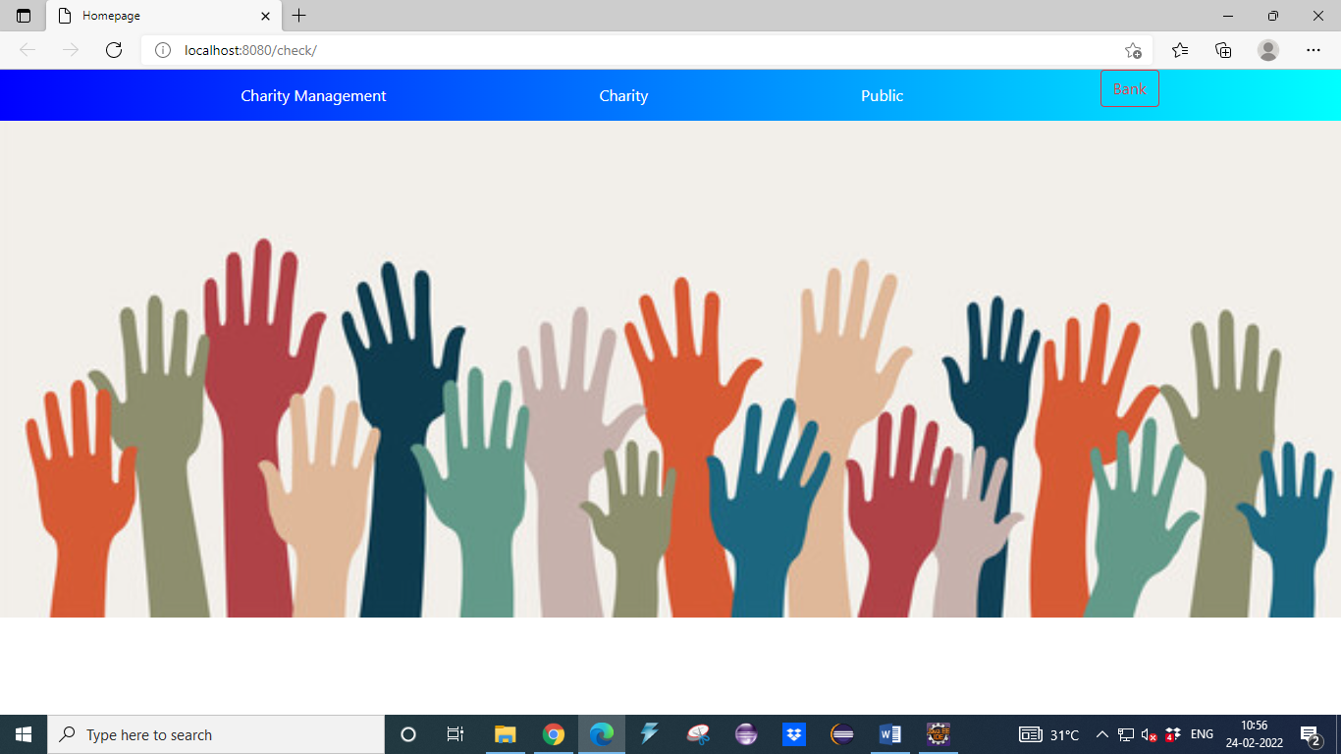

FIG NO. A.1 MAIN PAGE

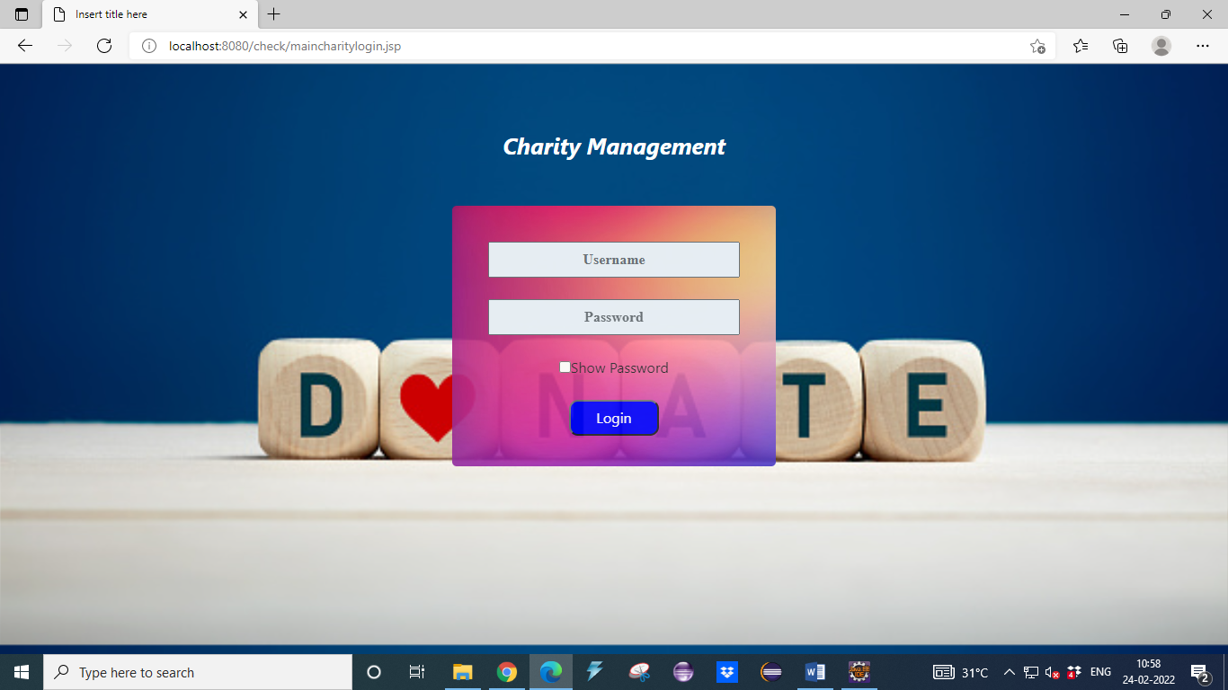

FIG NO. A.2 CHARITY MANAGEMENT LOGIN

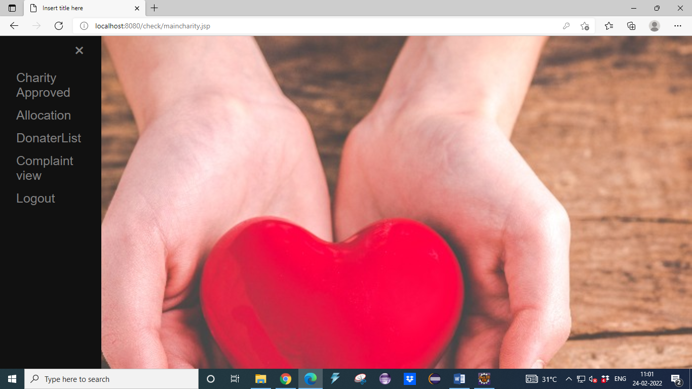

FIG NO. A.3 CHARITY MANAGEMENT MAIN PAGE

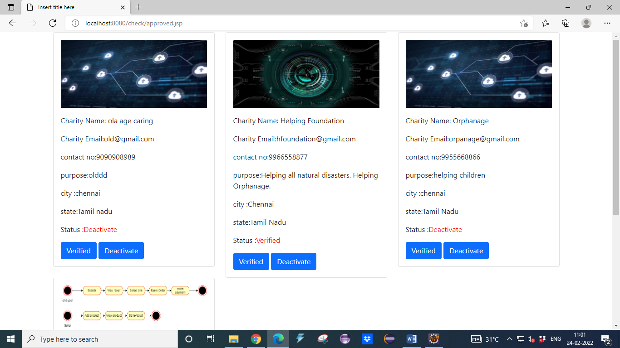

FIG NO. A.4 CHARITY APPROVE PAGE

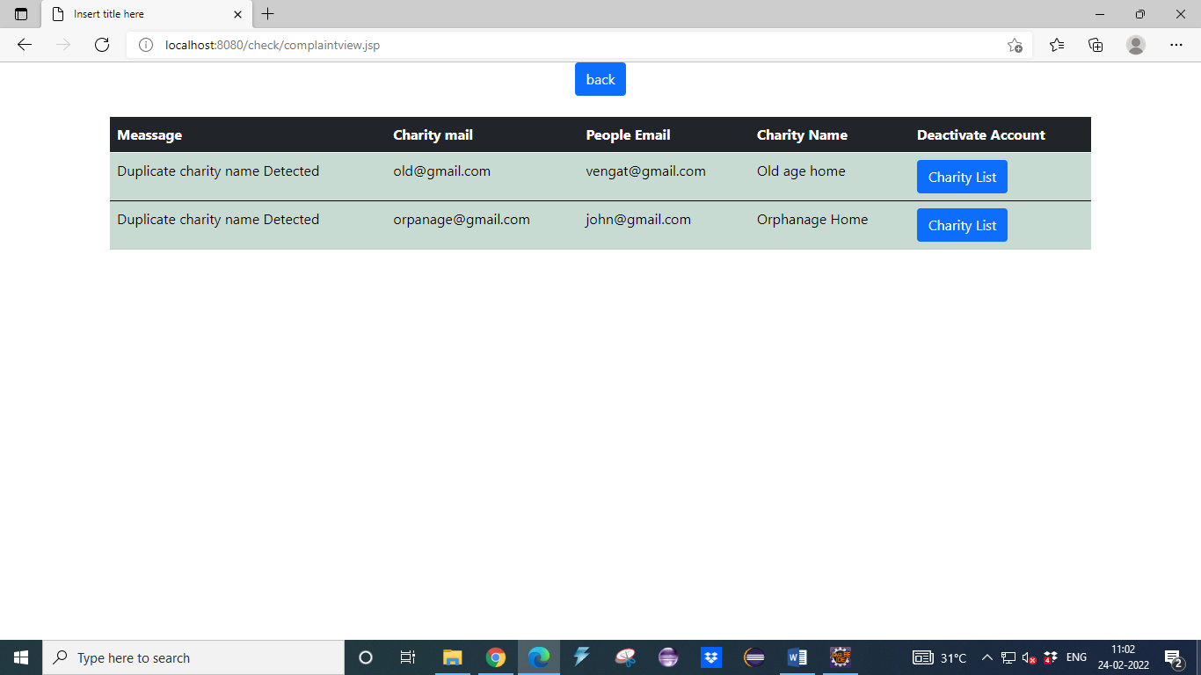

FIG NO. A.5 CHARITY COMPLAINT VIEW

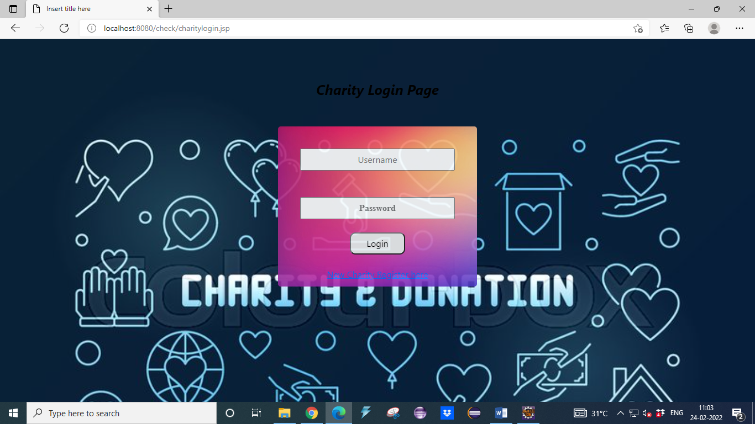

FIG NO. A.6 CHARITY LOGIN PAGE

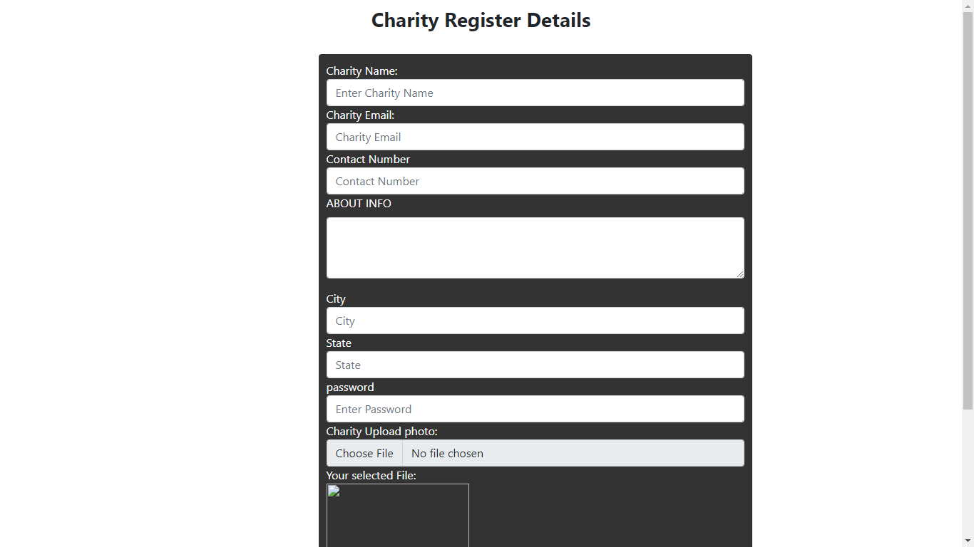

FIG NO. A.7 CHARITY REGISTER PAGE:

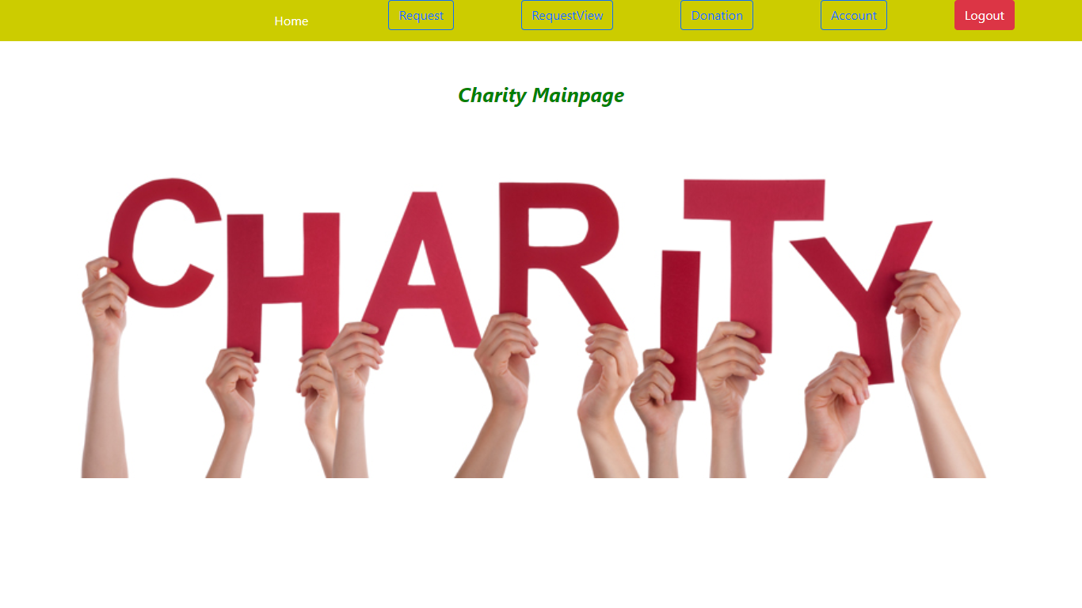

FIG NO. A.8 CHARITY MAIN PAGE

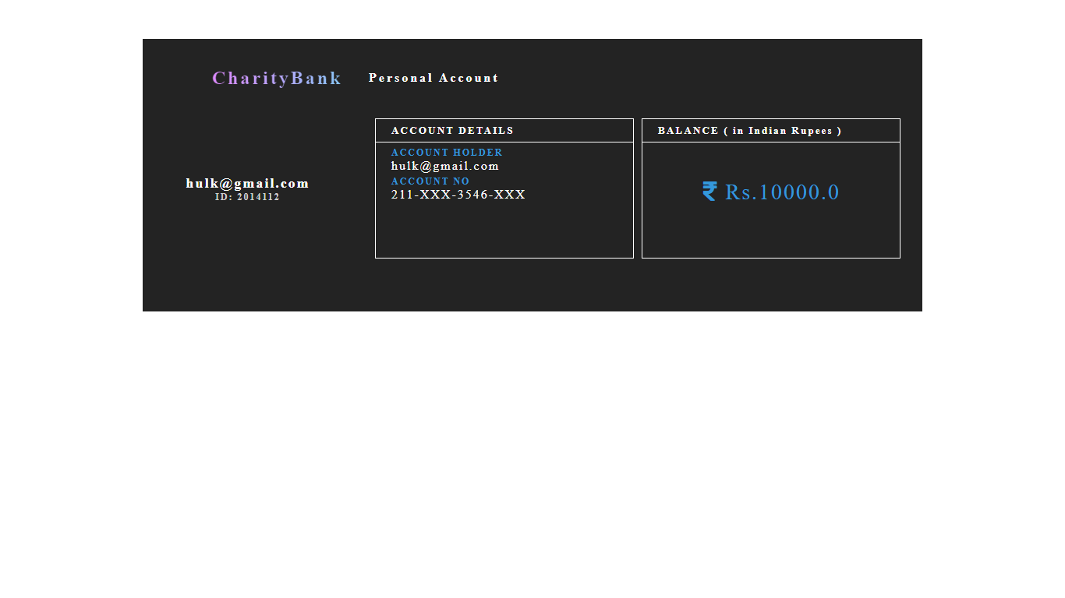

FIG NO. A.9 CHARITY ACCOUNT VIEW

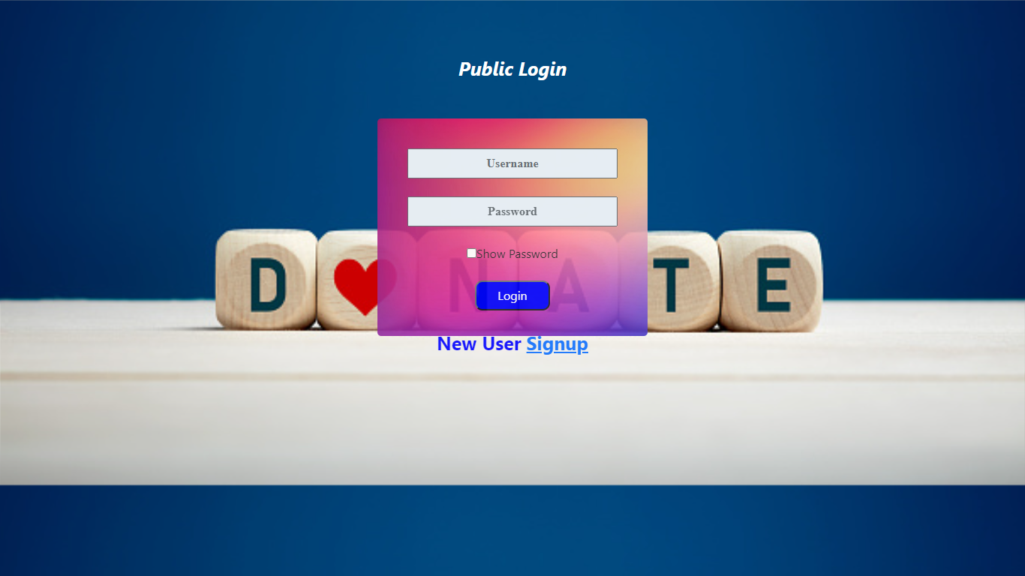

FIG NO. A.10 PUBLIC LOGIN PAGE

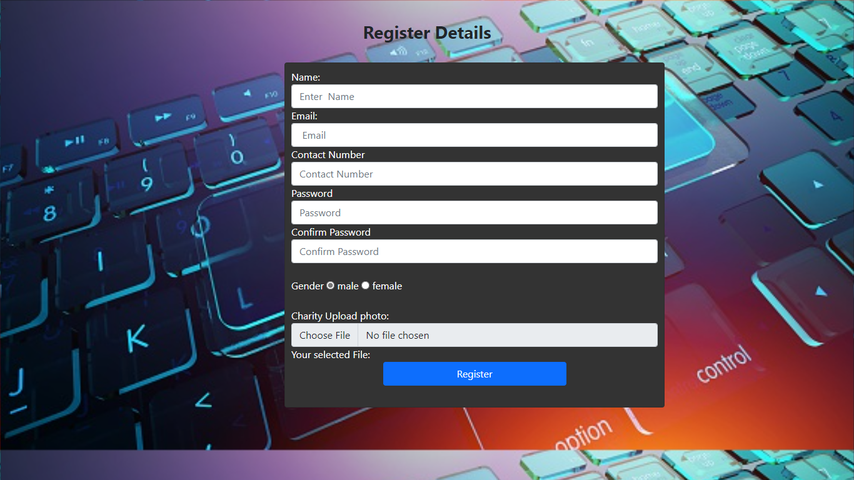

FIG NO. A.11 REGISTER PAGE

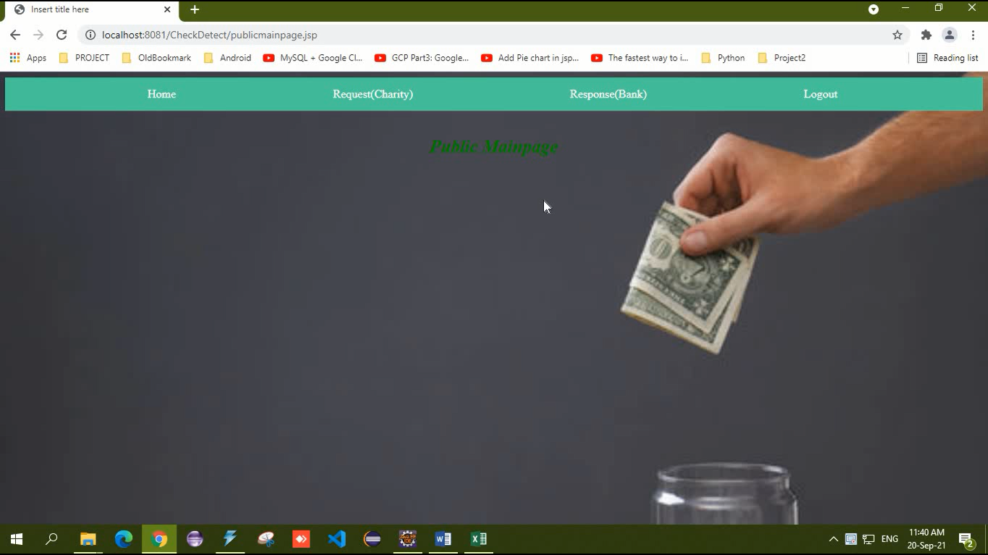

FIG NO. A.12 PUBLIC MAIN PAGE

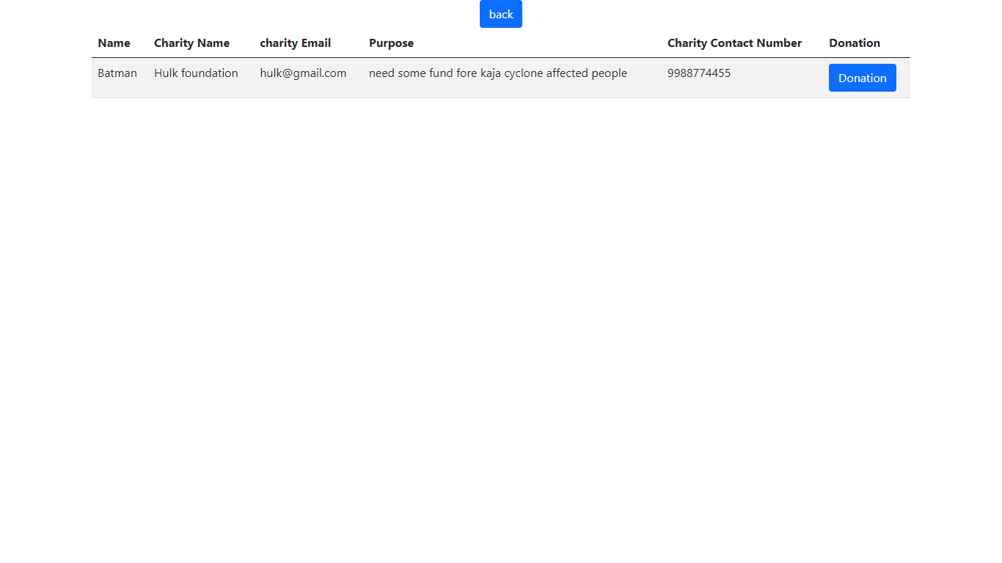

FIG NO. A.13 PUBLIC REQUEST VIEW

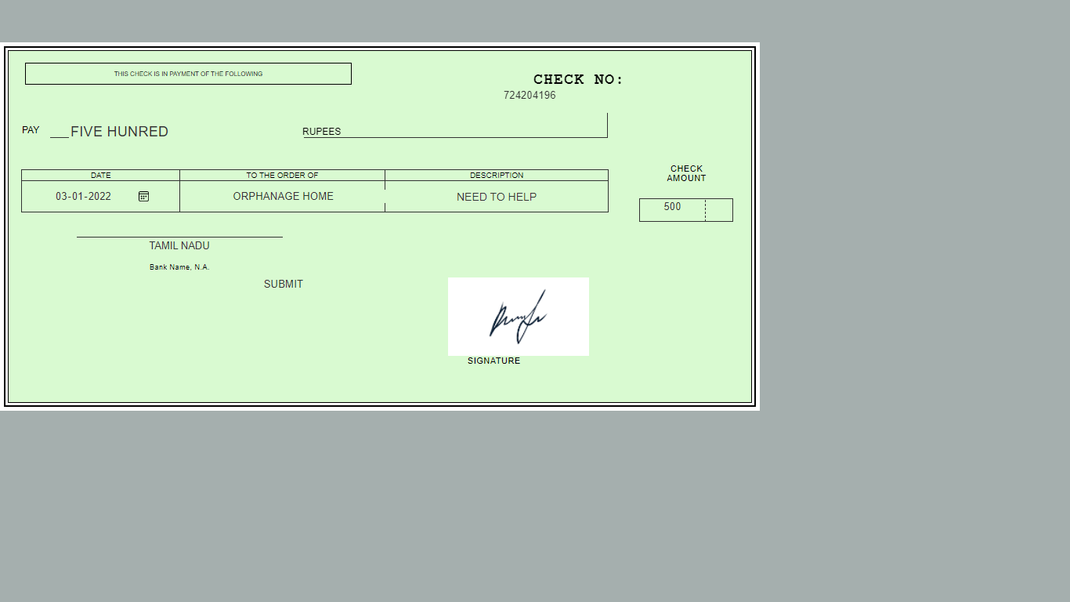

FIG NO. A.14 CHEQUE VIEW PAGE

**REFERENCES**

[1] Badis Hammi, Sherali Zeadally, Yves Christian Elloh Adja, Manlio Del

Giudice,and Jamel Nebhen. (2021) “Blockchain-Based Solution for Detecting and preventing Fake Cheque Scams”.

[2] Emart 77, Beirut,Lebanon. (2021) “The Role of Blockchain in Reducing the Cost of Financial Transactions in the Retail Industry”.

[3] Dilip Kumar Sharma, Sonal Garg, Priya Shrivastava. (2021)“Evaluation of Tools and Extension for Fake News Detection”.

[4] Vikash Kumar Aggarwal, Nikhil Sharma, Ila Kaushik, Bharat Bhushan, Himanshu. (2020) “Integration of Blockchain and IoT (B-IoT): Architecture,

Solution,& Future Research Direction”.

[5] Jackie Jones, Damon McCopy. (2020) “The Cheque is in the Mail: Monetization of Craigslist Buyer Scams”.

[6] Abiola, Idowu. (2019) “ An Assessment of Fraud and its Management in

Nigeria Commercial Banks”.

[7] Sumeet Kumar. (2018) “ Simulating DDOS attacks on the us fiber-optics

internet infrastructure”.

[8] Nazli Ismail Nawang . (2017)“ Combating anonymous offenders in the cyberspace: An overview of the legal approach in Malaysia”.

[9] Haris Semic ,Sasa Mrdovic. (2017) “IoT honeypot: A multi-component solution for handling manual and Mirai-based attacks”.

[10] Bernie S.Fabito,Angelique D.Lacasandile ,Emeliza R.Yabut .(2017)

“Leveraging crime reporing in Metro Manila using unsupervised crowd-sourced data: A case for the Report framework”.

[11] Wendy Baker-Smemoe, Chair David Eddington William G. Eggington. (2015) “ The Language and Cross-Culture Perceptions of Deception”.

[12] S.Baker .(2018) “Don’t cash that cheque: BBB study shows how fake cheque scams bait consumers”,Tech Rep., Better Bus Bureau ,Arlington Country,VA,USA.

[13] L. M. Rose. (2018) “Modernizing cheque fraud detection with machine learning”,Phd.D. dissertation, Dept. Financial Crime Compliance Manage., Utica College ,Utica, NY, USA.

[14] Federal Trade Commission.(2018),“Consumer Sentinel network data book 2017”, Federal Trade Commission ,Washington, DC, USA, Tech. Rep.

[15] C. Tressler.(2020), “ FTC: The bottom-line on fake cheques scams”, Federal Trade Commission ,Washington , DC ,USA , Tech. Rep.

[16] “2017 Internet crime report ”.(2018) Federal Bureau of Investigation/Internet Crime Complaint Center, Washington ,DC ,USA, Tech. Rep.

[17] K. Pak and D. Shadel. (2011)“AARP Foundation national fraud victim study ”, AARP Foundation , Washington , DC, USA, Tech.Rep.

[18] C.-D. Chen and L.-T.Huang. (2011) “Online deception investigation: Content analysis and cross-culture comparision”, Int. J. Bus. Inf., vol. 6, no.1, pp.91-111.

[19] K. Christidis and M . Devetsikiotis. (2016) “Blockchains and smart contracts for the Internet of things” , IEEE Access, vol.4 , pp.2292-2303.

[20] A.Reyna , C.Martin, J. Chen ,E. Soler ,and M. Diaz .(2018) “On blockchain and its integration with Iot: Challenges and opportunities”, Future Gener . Comput .Syst., vol.88 ,pp.173-190.

[21] M.T. Hammi, B. Hammi, P. Bellot, and A. Serhrouchni.(2018) “Bubbles of trust: Adecentralized blockchain-based authentication system for IoT”, Comput. Secure., vol. 78, pp. 126 - 142.

[22] R. M. Factora. (2014)“ Financial and legal methods to protect individuals from financial exploitation in Aging and Money” , Newyork, NY , USA: Springer, pp .109 - 122.

[23] C. W. Smith.(2001) “Defence to a payor bank’s liability for kate returns”, CCH Deposit Law Notes , vol. 2, no.6, p. 8.

[24] A. T. Riggs and P. M. Podrazik. (2014) “Financial exploitation of the elderly: Review of the epidemic - Its victims, national impact and legislative solutions”, in Aging and Money. New York, NY, USA: Springer, 2014, pp.1 – 18.

[25] J. Jones and D. McCoy.(2014)“The cheque is in the mail:Monetization of Craigslist buyer scams”, in Proc. APWGSymp. Electron. Crime Res., 2014, pp. 25 – 35 .

[26] I.Abiola. (2009) “An assessment of fraud and its management in Nigeria commercial banks”, Eur. J. Social Sci., vol.10, no.4, pp.628 – 640.

[27] J. A. Ojo, 2008, “Effects of bank frauds on banking operations in Nigeria”, Int. J. Investment Finance, vol. 1, no. 1, p, 103.

[28]S. Chhabra, G. Gupta, M. Gupta, and G.Gupta.(2017) “Detecting fraudulent bank Cheques”, in Proc. IFIP Int. Conf. Digit. Forensics, pp.245 – 266.

[29] R. Kumar and G. Gupta. (2016)“ Forensic authentication of bank cheques”, in Proc. IFIP Int. Conf. Digit. Forensics, pp. 311 – 322 .